**Q9 Report:**

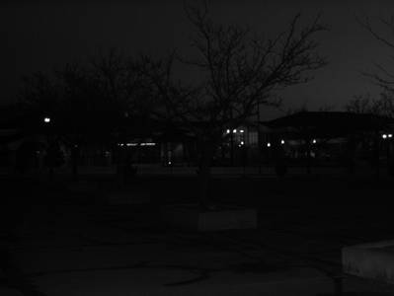 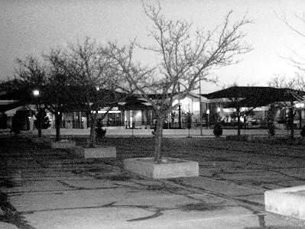

Original Global Histogram equivalised

Local Histogram equivalised images(specified with neighborhoood size):

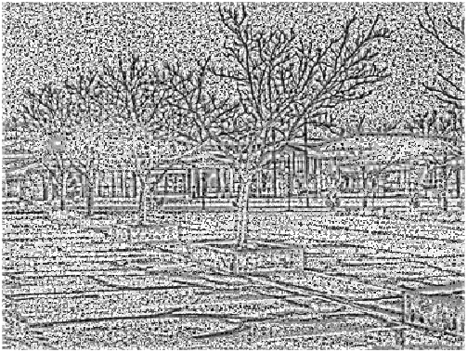 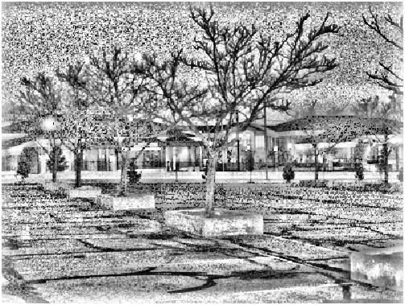

7 x 7 31 x 31

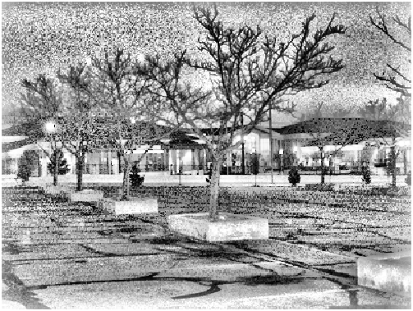 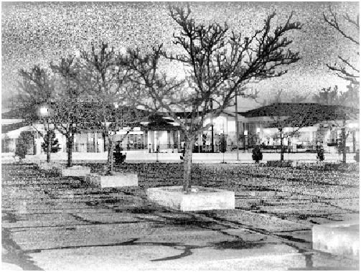

51 x 51 71 x 71

In local histogram equivalization, it’s easier to spot objects in the background which have a relatively lower intensity compared to the rest of the image. There, it produces better local contrast than global histogram equivalization

The outlines of objects are also more clearly visible in the locally equalized images.

**LC2:**

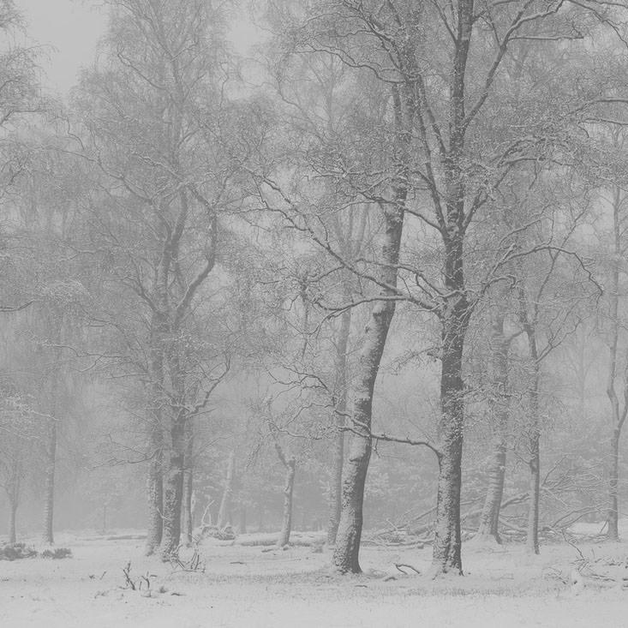 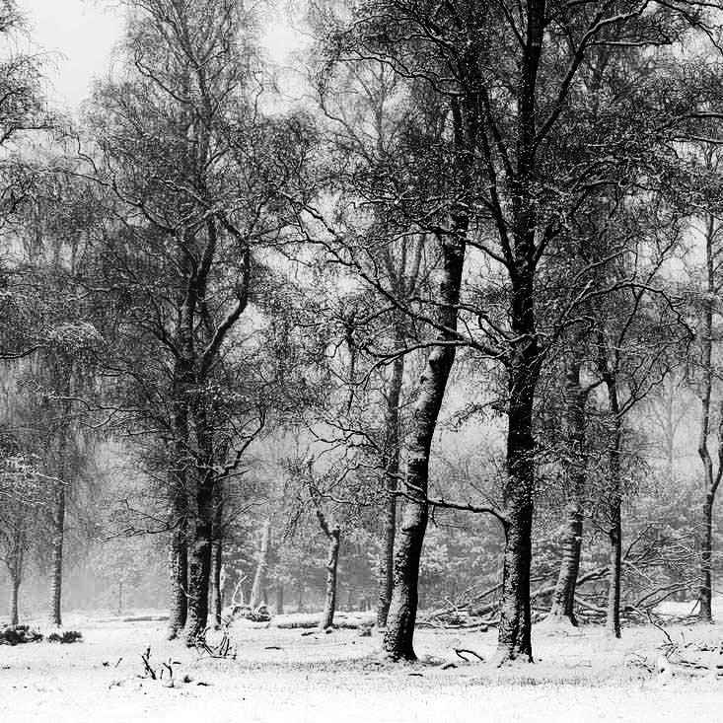

Original Global Histogram equivalized

Local histogram equivalization with different filters:

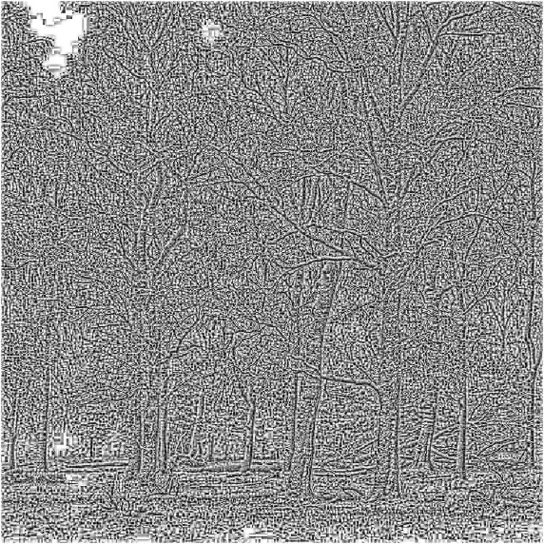 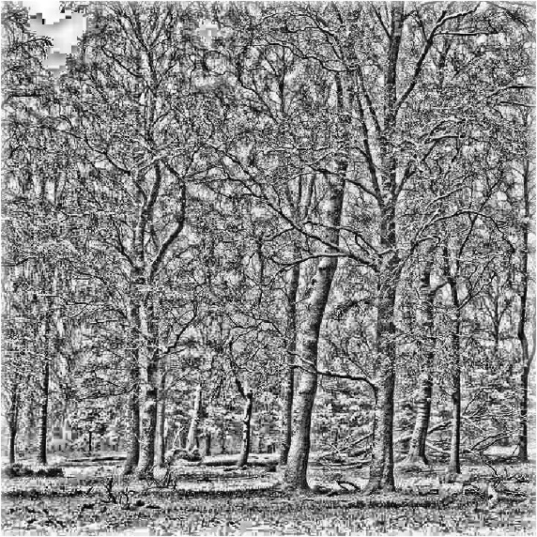

7 x 7 31 x 31

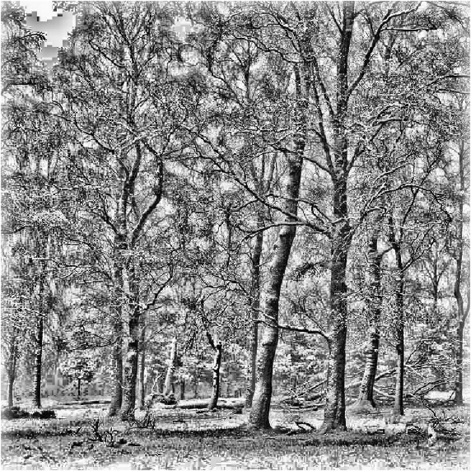 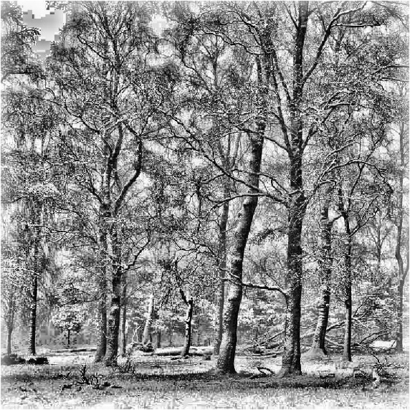

51 x 51 71 x 71

The local method produces better contrast at trees in the back where, the intensity doesn’t vary much locally in the original and globally equivalized images. It also has produced higher contrast at the bottom near the snow.